RDCH 702 Name:__________________________________
Quiz 3
Assigned 14 November 12, Due 21 November 12

Quiz Topics: Electronic Orbitals and Energetics, Decay Kinetics, Nuclear Models, Radiation Interactions
Use the lecture notes, chart of the nuclides, table of the isotopes, and web links to answer the following questions.

- (10 Points) What are the possible structures for a 5 coordinate compound? How are the structures related?

- (10 Points) What is the relationship between molecular orbital theory, crystal field theory, and ligand field theory?

- (10 Points) The earth is 4.5E9 years old.
  - Provide the ²³⁵U to ²³⁸U ratio at the origin of the earth.
  - Provide the ²³⁵U to ²³⁸U ratio 1 billion years from today.

- (15 Points) You have a sample of ⁹⁵Zr that is counted for 1 minute and has an activity of 702 Bq. Consider this the activity at time zero. Please provide the activity in Bq and the % error in the counts for the following times after time zero for 1 minute counting. Assume you have 100 % detection for each decay, so the total counts is equal to the total decay that occurs in 1 minute.

Time (days) | Activity (Bq) | % error
0 | 702
10
65.0
100
135.8
365
505

- (20 Points) Using the Shell model find the spin and parity of the following isotopes. Compare with the actual values. Explain any differences.
- ⁶⁷Ni  - ⁶⁴Cu  - ³⁰Si  - ⁴⁶Sc  - ¹⁴⁵Sm  - ²⁰¹Hg  - ²⁰⁴Tl  - ²⁴²Am  - ²³⁹Pu  - ²¹¹Fr  - ²⁰⁶At  - ¹⁷⁹Hf | 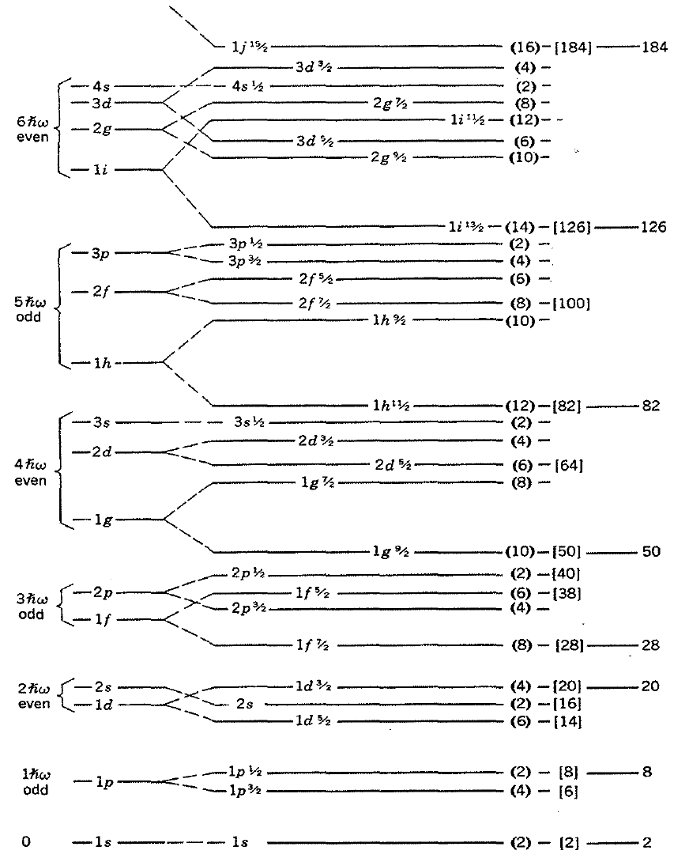

- (10 Points) Consider the isotope ¹⁹Ne. What is the shape of the nucleus based on the observed spin and parity using the Nilsson diagram?

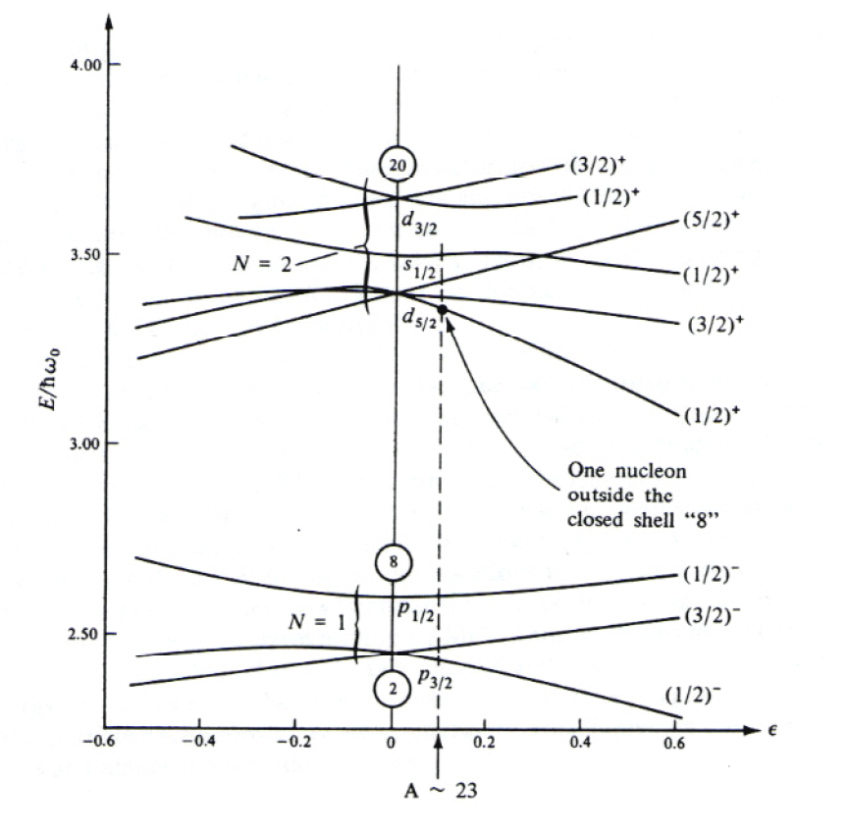
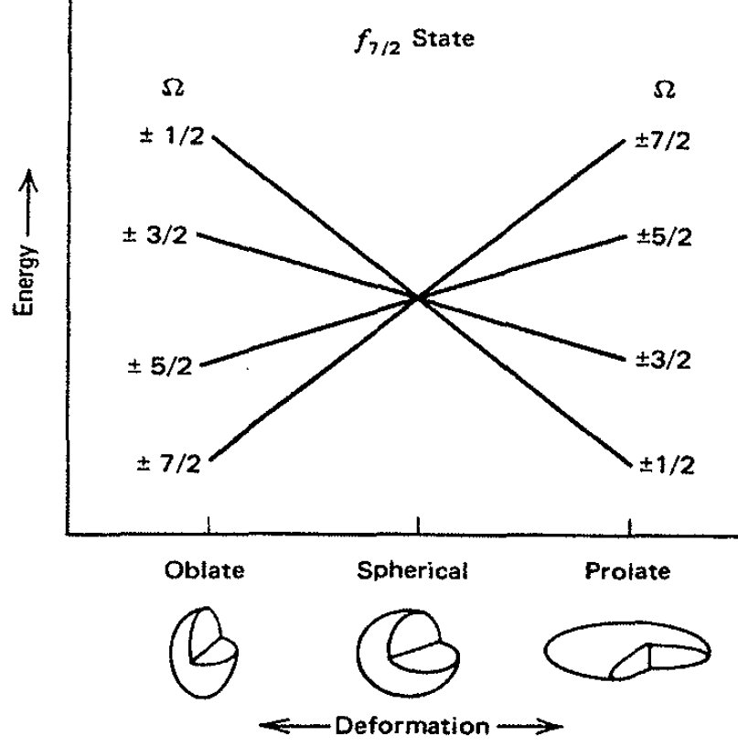

- (20 Points) Please provide the maximum mass of the radionuclide permissible for research based on the conditions below.
Radionuclide | Rad Safety Level | Condition | Mass (mg)
⁹⁹Tc | 2 | In solution of UV-Visible spectroscopy
⁹⁹Tc | 3 | Airborne in Fume hood
⁹⁹Tc | 3 | Airborne in glove box
²³²Th | 3 | Non-airborne, benchtop
²³⁵U | 3 | Airborne in Fume hood
²³⁸U | 3 | Airborne in Fume hood
²³⁸U | 3 | Airborne in glove box
²³⁷Np | 3 | Non-airborne, benchtop
²³⁷Np | 3 | Non-airborne, fume hood
²³⁷Np | 3 | Airborne in Fume hood
²³⁷Np | 3 | Airborne in glove box
²⁴³Am | 2 | Non-airborne
²⁴³Am | 3 | Non-airborne, benchtop
²³⁹Pu | 3 | Non-airborne, benchtop
²³⁹Pu | 3 | Airborne in Fume hood
²³⁹Pu | 3 | Airborne in glove box

- (5 Points) When is breathing zone monitoring needed for Rad Safety Level 3 work?

